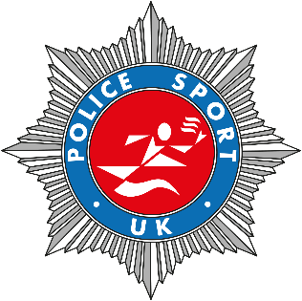

PSUK Marathon Championships 2026
Entry Details
We are pleased to announce that this year the PSUK Marathon Championships will take place within the Langdale Marathon on Saturday 17th October 2026 in partnership with Lakeland Roads.
In complete comparison to last year’s marathon, the Langdale Marathon is hilly but will provide stunning views around the Lake district national park. A great opportunity to come and explore this beautiful area. Bring the family, friends. Colleagues and make an occasion/holiday of it.
PSUK have been provided with a bespoke entry system so please read this entry form thoroughly and follow the correct process.
For information about the marathon please follow this link:
https://www.lakelandroads.org/marathon
Once you have read the marathon details and you wish to enter this must be done following a 2 stage process.
ENTRY INFORMATION:
To enter you must compete 2 stages! Together
- Stage 1. Open the below link and follow the instructions to register and then enter the Police Champs Langdale marathon.
- https://entries.lakelandtrails.org/enter/73647/police-marathon-championship-entry/
- When completing your team/club use your Police Force name. E.G Essex Police. This is required for the results.
- You will only be required at this point to pay a £10 non-refundable deposit to the host. You will then need to pay PSUK/Me the remaining balance [Stage 2]. As Lakelands Roads have given us a discount you will be unable to transfer any entry to any other race if you pull out other than a 5k.
- At this point you can also elect to pay for an event T shirt in addition to the £10.
- The entry portal is for PSUK membership only and should not be shared outside.
- Provide the host with the same email address you provide PSUK/Me.
- Stage 2. Once you have entered the race you then must compete your entry details below and send it to me along with the entry fee immediately after completing Stage 1.
- The costs are as follows: Race and PSUK entry £62 [£10 deposit paid at point of entry]; Total £62. Presentation function £30.
- Reference your payment as LM26/your initials and force E.G KW/Hampshire
- Scan/photo and/or email the form to me and confirm you have transferred the funds.
All the information you require about the marathon such as time, registration, parking etc can be found on the Lakelands Roads website. Please read it thoroughly.[Link above]
You will be eligible for open awards. A presentation will take place at the race venue at 1600 hours on race day..
PSUK Results are based on gun time!
The closing date for the PSUK Championship is Friday 18th September.
Presentation function: The Police presentation will take place directly after the open awards at 1630 hours at Lanty Slee’s, Stickle Barn, Langdale, Cumbria LA22 9UJ [Hayloft – upstairs: https://lantyslangdale.com/private-hire/ ]. . We have the private room upstairs but the bar will be open all day so you can come along and relax/celebrate your achievement prior to the start of our function. This is in close proximity to the event village.
There will be a hot buffet along with bread and salad followed by a hot desert. Tap water will be provided. There are table and chairs to accommodate your tired legs. Dietary requirements will be catered for.
Lanty Slee is a stunning atmospheric venue so I do hope you can join us and applaud those award winners, chat and greet your colleagues. https://lantyslangdale.com/
PSUK Marathon – It’s your responsibility to find your own accommodation and book it.

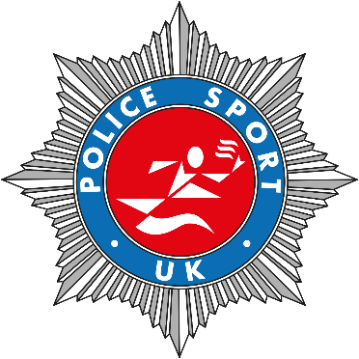
PSUK Marathon Entry Form
COMPLETE USING BLOCK CAPITALS [Closing date 18/09/26]
Full Name………………………………………………………………………………………………………….
Force………………………………………………………
D.O.B………………………………………………………..AGE on Race day…………………………….
Contact email address:………..……………………………………………….……………………………
Telephone contact……………………………………………………………………………………………
Emergency contact name:………………………………………………………………………………..
Emergency contact telephone number:……………………………………………………………
Medical condition: [Should be written on back of number]:…………………………….
…………………………………………………………………………………………………………………………
………………………………………………………………………………………………………………………….
Race and PSUK entry = £62 [£10 deposit already paid] Remaining sum to pay PSUK is £52 …………………………………………………
Presentation function £30………………………………………………………………………………….
Dietary requirements:……………………………………………………………………………………….
No. Guest/s ……………………….. Cost per guest £30 Total = £………………….…….…
Dietary requirement guest/s……………………………………………………………………………..
Force team manager: [If team entry]……………………………………………………………….
Scan or email form to kwpsukas@btinternet.com AND Bacs payment to:
Mrs Katherine A Willoughby
Sort Code: 60-07-01
A/C No: 47211725
Reference: LNM26[followed by your initials/force] [Reminder – minimum entry is race + PSUK entry = £10 Deposit paid at point of entry + £52 to PSUK]
The email you send your entry form to me will be the email I use for any further correspondence to you.

Your personal details entered above have been provided by you. Art. 6 par. 1 lit, and art. 7 of European General Data protection Regulation ‘GDPR’ refers. This allows for the use of your personal data before, during and after the competition, as well as subsequent documents, photographs and videos that may be produced, for example by PSUK. By providing these details you have consented to the GDPR agreement.
Signature…………………………………………………………………………………………………………
If you wish to opt out of this GDPR agreement please specify if in full or specific areas.
Awards will be provided as follows:
Mandatory awards:
Open category: First 3 men/women
Team Award: First 3 teams [First 3 team members over the line]
Additional awards are all dependant on number of entries per category:
- Team Awards: First 3 men’s team of 3; first 3 women’s team of 3
- Vet categories women : FV35, FV40, FV45, FV50, FV55, FV60 and over –
- Vet categories men: MV40, MV45, MV50, MV55, MV60, MV65 and over
This is a championship race. No award will be provided if there is only 1 athlete in an age group.
If 5 vets in each category enter 3 awards will be given. If 3 or 4 enter only 1st and 2nd will be awarded. If 2 enter only 1st will be awarded.

Good luck with your training and we look forward to seeing you in Langdale

