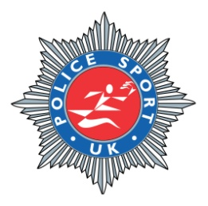

POLICE SPORT UK
TRACK AND FIELD CHAMPIONSHIPS
QUEENS PARK ATHLETICS STADIUM
INVERNESS
WEDNESDAY 30TH MAY 2012

FORCE:

Number of team entries: -................ (£100 per team) £
(Packed lunch for each person included in initial entry fee)
Additional Weight: - ........................ (£15 per team per event) £
Additional Weight: - ........................ (£15 per team per event) £
Additional Weight: - ........................ (£15 per team per event) £

No. of places required at Presentation Meal/Function: -..........................

Presentation Meal/Function (£10 per head) X Number of Places Required £
Total £_________

We will require transportation from Inverness (Dalcross) Airport: - Yes/No
Number of competitors requiring transportation: Flight arrival time: 29th May @
We will require transportation from Inverness West Premier Inn to the Evening Function: Yes/No
Number of competitors requiring transportation:
We will require transportation from Holiday Inn Express, Stoneyfield to evening function:- Yes/No
Number of competitors requiring transportation: -.................................

Total - £__________

The closing date for entries is Friday 20th April 2012. No late entries can be accepted. No entries on the day and there can be no refunds for non attendance.

Team Captains should return the entry forms to the following address:
Insp David Ogilvie, Policy & Co-ordination Unit, Police HQ, Old Perth Road, INVERNESS, IV2 3SY.

Cheques should be made payable to ‘Northern Constabulary Sports & Athletics Club”.

Alternatively payment can be taken by Bank Transfer:

Sort Code : 80-06-87
Account No.: 00874032
Northern Constabulary Sports and Athletic Club

Any issues re bank transfers to be addressed with Joyce Jack on 01463 720278.

Any further information can be obtained from the above address, by e-mail on david.ogilvie@northern.pnn.police.uk or by calling Inspector David Ogilvie on 01463 720834

Ropes and Scales will be on site. Any other equipment must be brought by competitors.

Events for competition at the Championships
640k, 680k, 720k, catch weight

*Sponsorship may allow for the provision of a commemorative tee shirt to be issued to competitors.

In the event that this occurs please indicate a size: S / M / L / XL / XXL / XXXL

