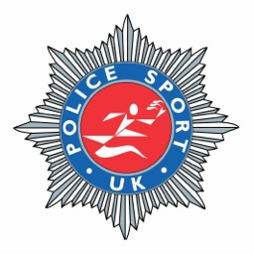
MARATHON CHAMPIONSHIPS 2014

The 2014 PSUK Marathon Championships will be held in conjunction with the Milton Keynes Marathon on Monday 5th May 2014 (May Day Bank Holiday) – Further Details to Follow…
In October 2014 the USPE (European Police) Marathon Championships are being held in Austria.
The selection criteria for these Championships are as follows:-
Men and women must be serving police officers.
(Sorry – PSUK have tried to appeal against this decision but at present the USPE rule still stands).
MEN
1. All athletes run a marathon between 1.09.2013 and 31.05.2014 in sub 2hrs.45mins.
2. First two male athletes in the 2014 PSUK Marathon, to be staged in Milton Keynes on Monday 5th May 2014 will be automatically selected, providing qualifying time is achieved in this race.
3. Up to four more other athletes will also be selected from any performance in qualifying period, providing qualifying time achieved.
4. PSUK hope to select SIX male athletes for the USPE Marathon but this may be reduced if the qualifying standard has not been achieved.

LADIES
1. All Athletes run Marathon between 1.09.2013 and 31.05.2014 in sub 3hrs. 05mins.
2. First two female athletes in the 2014 PSUK Marathon, to be staged in Milton Keynes on Monday 5th May 2014 will be automatically selected, providing qualifying time is achieved in this race.
3. Up to four more other athletes will also be selected from any performance in qualifying period, providing qualifying time achieved.
4. PSUK hope to select SIX female athletes for the USPE Marathon but this may be reduced if the qualifying standard has not been achieved

Sally Broome
Secretary PSUK Athletics Committee

