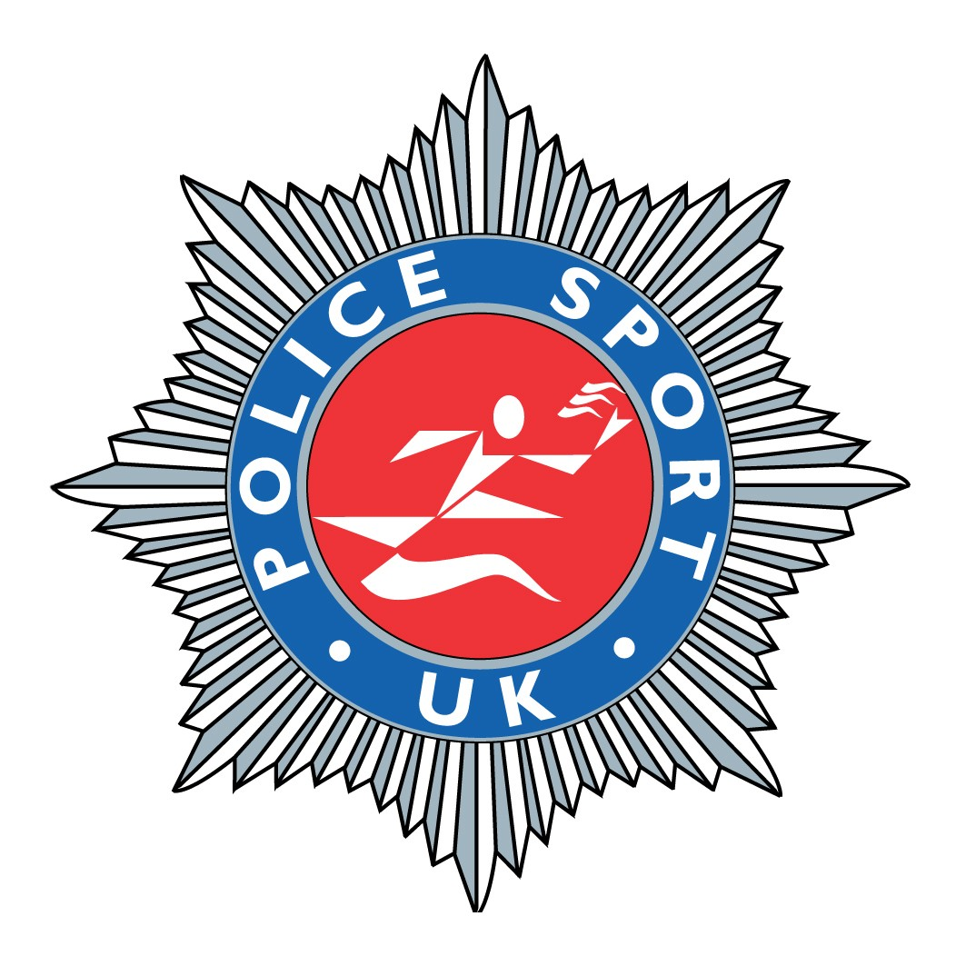
SC 9785 Steven Broadbent
Carnforth Police Station
Grosvenor Road
Carnforth
LA5 9DQ

Work Tel: 01524 596424
Home Tel: 01539 824654
Mobile: 07974795466
Fax: 01524 596446
Email: steve@policesport.net
20 February 2008

Dear Colleague

British Police Fell Race Championships 2008

The 2008 British Police Fell Race Championships will take place from Mungrisdale, Cumbria on Tuesday 13 May 2008 starting at 1pm.

This event is sanctioned by the Police Sport UK but is not an official Police Sport UK Championship event. The race venue and course for the 2008 event has been kindly assisted by members of Cumbria Constabulary Athletics Section.

Race Venue, Race Registration and Presentation Venue

The fell race course is over Bowscale, Blencathra and Souther Fells. The race registration, start, finish and post race presentation will take place from the Mill Inn, Mungrisdale, Penrith CA11 0XR.
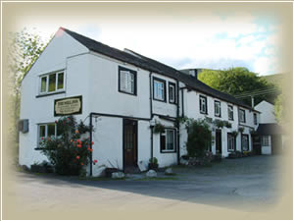
Accommodation

As usual, there is no official accommodation provided. Competitors are asked to make their own arrangements.

Suggested accommodation close by:

• Mill Inn, Mungrisdale
Tel No 01768 779632

• Travel Lodge, Penrith
Tel No 0871 9846168
(Just off M6 Jct 40 towards Keswick)

• Near Howe Guest House, Near Mungrisdale
Tel No. 017687 79678

There are plenty of other small hotels and bed and breakfasts houses in the area. These are advertised on the Lake District Tourist Information Website.

Directions

From M6 (Heading North or South) Exit at Junction 40 Penrith and follow signs for the A66 west to Keswick. Follow the A66 towards Keswick for approximately 9 miles then turn right signposted Mungrisdale and Caldbeck. Continue along this road for approximately 2.5 miles into Mungrisdale village.

Parking

The Mill Inn has asked that we do not park in their main car park as it may detract other custom. There is plenty of parking on the approach to Mungrisdale village on the verges. There is also limited parking in front of the village hall which is very near the Mill Inn.

Shower and Changing Facilities

As with most fell races, shower and changing facilities are not provided. Runners should improvise by changing from their vehicle and washing off in the nearby stream in Mungrisdale.
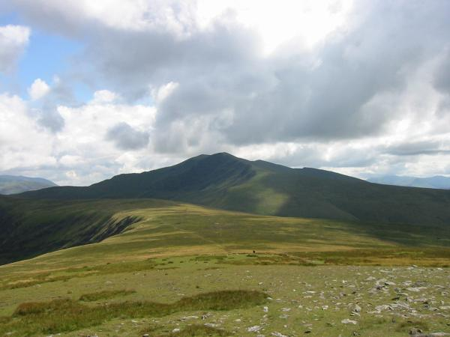
Course

The start and finish is only a two minute walk from registration. The initial ascent and final decent off Souther Fell will be controlled by flags. The choice of route outside the controlled sections is your own.

Start Fell Gate, Mungrisdale (GR 361303)
CP 1 Bowscale Fell Summit (GR 333306)
CP 2 Blencathra Summit (GR 323278)
CP 3 Souther Fell Summit (GR 355292)
Finish Fell Gate, Mungrisdale (GR 361303)

The three check points will be manned. Race numbers should be given verbally to the marshal.

The route is a demanding course over open fell-land. It is approximately 9 miles with 2,700 ft of ascent.

(Picture: Blencathra from Bowscale Fell)

Kit Requirement

Competitors will need to carry the following equipment:-

1. Windproof whole body cover
2. Map, Compass and Whistle
3. Suitable footwear for fell running
4. Waterproof body cover (Only if poor weather conditions)

This is a serious event over difficult terrain. Each competitor should have navigational skills.

Entry Field

The Championships are likely to attract between 50 and 70 runners from 20 UK police forces.

Registration and Pre-Race Briefing
Registration will be in the Mill Inn public house from 11.00am to 12.45pm. Race numbers and pins will be issued. A final pre-race briefing will take place at 12.45pm at the Mill Inn.

Post Race Meal and Presentation of Trophies

A hot meal will be provided from 2.30pm in the Mill Inn followed by a formal presentation of trophies and prizes at approximately 3.30pm.

Trophies /Prizes

Men:

1st, 2nd and 3rd - Open
1st, 2nd and 3rd - Vet 40+
1st - Vet 45, Vet 50
1st, 2nd and 3rd Open Force Teams (First three to count including ladies)
1st - Veteran 40+ Team (First three to count)

Women:

1st, 2nd and 3rd - Open
1st - Vet 35+

NB. Additional prizes may be added subject to entry volume.

British Police Fell Race Entry

The entry fee will be £15.00. This fee covers the cost of the presentation buffet and the awards and prizes. The official entry form accompanies this document.

Qualification

Competitors must be fully paid members of their respective force sports clubs and be a police officer, police staff, retired police/police staff (in receipt of a police pension) or member of the special constabulary/police volunteers. (If in doubt please refer to the www.policesportuk.com website for a detailed definition)

Pre-Race Recognisance

There are no objections to teams or individuals reconnoitring the course.

Closing Date

The closing date is Friday 2 May 2008 - There are no entry fee refunds but substitutions to pre-paid entries will be allowed on the day.

Entry Confirmation

Team managers will receive a confirmation of your entry and any late briefing information by email.

To view our own dedicated web-page with information specific to the British Police Fell Race Championships including entry forms, itinerary documents and final results go to:

www.policesport.org

Please do not hesitate to contact me if you have any further questions or require any other information.

I will await entries from you and your team and will look forward to seeing you in May.

Yours in sport,

Steve

SC 9785 Steve Broadbent
Police Sport UK Athletics Section – British Police Fell Race Coordinator

Work Tel: 01524 596424
Home Tel: 01539 824654
Mobile: 07974795466
Fax: 01524 596446
Email: steve@policesport.net

